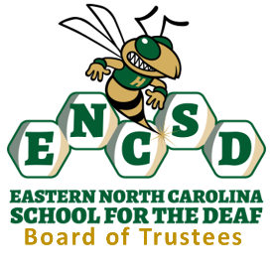

June 9, 2026
9:00 AM
Massey Conference Room

1. Call to Order
Chairman Ken Jones called the regular meeting of the Eastern North Carolina School for the Deaf (ENCSD) Board of Trustees to order. The Pledge of Allegiance was performed. Roll call was completed.
2. Roll Call
Ken Jones
Gary Farmer
Kevin Earp
Dr. Dave Dolman
Sharon Lott
Absent were:
Rob Boyette
Also Present Were:
Rachel Hitch - Attorney
Cheryl Iannucci – Superintendent
Mandy Armstrong – Clerk of the Board
3. Approval of Agenda
Motion: Mr. Farmer moved to approve the agenda as presented
Second: Mr. Kevin Earp
Vote: All in favor. Motion Carried.
4. The Board received training in the following:
- Board Governance, Duties, and Responsibilities Workshop – Rachel Hitch
- Open Meetings/Public Records – Rachel Hitch
- Ethics and Conflict of Interest Workshop – Rachel Hitch
- Board Role in Personnel Matters Discussion – Simone Leigh
5. Board Member Remarks and Reminders
6. Chairman’s Comments
7. Adjournment
There being no further business, the meeting was adjourned.

Minutes submitted by: Mandy Armstrong
Date: June 9, 2026

